Editing Ads That Convert
Editing Ads That Convert

Introduction

This SOP breaks down how to edit an ad that actually converts, from A to Z, with a live breakdown.

Video Breaking This Down <<

What you need for this SOP:
- Premiere Pro (or any editing software that suits you)
- YouTube.com (to gather assets)
- Raw footage of the project

Beliefs & Principles
Being a good editor is not only technical; here are crucial principles you need to have in mind when editing video ads

Editing ads is sales, not cinema.

- Clarity beats cleverness: If a choice helps the viewer simply understand, believe, and act, keep it. Having a fancy-looking video doesn't cut it.

- Engagement doesn't end with the hook: Viewers decide every 1–3 seconds whether to keep watching. You win long retention by adding pattern breakers (zoom-ins, sfx, caption pops) that serve some curiosity/negative emotion/shock.

- The avatar dictates: pacing, music, language, and visuals, everything. There isn't good/bad music, there is music that fits/doesn't fit your targeted audience.

- Quality builds trust: if the audio and footage are of bad quality, people will naturally trust your ads less. It doesn't have to look top-notch, just not worse than your iPhone 11 camera.

- “Free” on the internet ≠ safe: keep in mind that some music, b-roll, and fonts are licensed.
Although it usually never happens, you can get your campaign shut down if you don’t have a proper license.

- Being organized and efficient: what sets apart good and great editors is speed. You can't be fast when your workflow is a mess. From experience, losing media/footage and not being able to find it is a big headache, so stay organised with different files and naming.

Live Breakdown
Now that we understand some core principles, let’s actually break down how to do it.

Setting up the composition
Create a new project file in the software you use, and adjust the resolution to your needs.

- Phone/vertical resolution: 1080x1920 (1080p)
- Computer/Horizontal resolution: 1920x1080 (1080p)
- Square/1x1: 1080x1080 (1080p)

In terms of frames, you should match it to the raw footage. (usually 29.97/30 fps).
To check the raw footage fps, go to the file, Right-click> Properties > Details.

Cleaning up the audio
clean voice = trust, trust = action

- Balance L/R: if one channel is louder, use the “Fill Left / Fill Right” effects
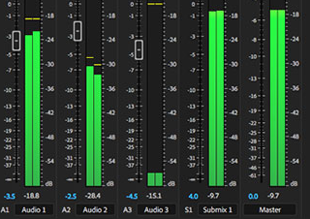

- Noise reduction: if the background sounds are loud, this should help out.
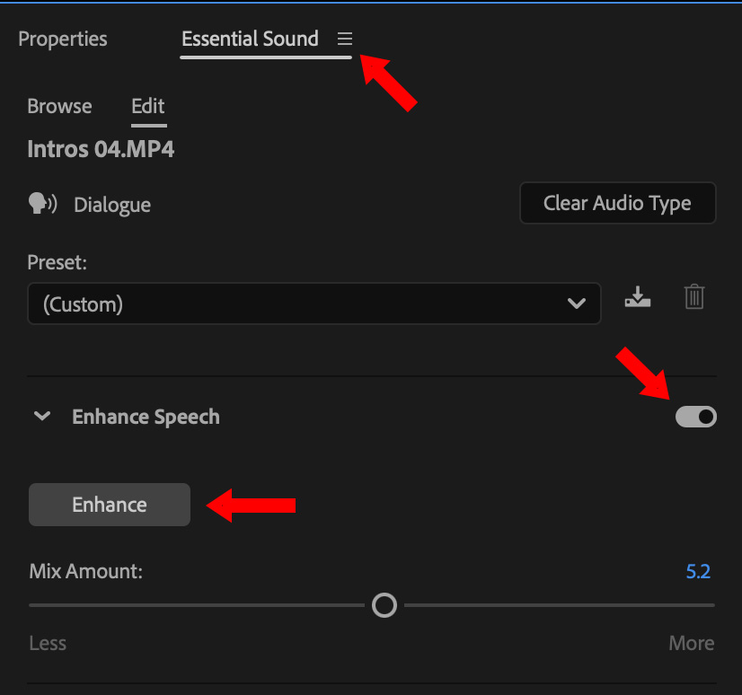

Color
If the footage looks like it was filmed in a cloud, your viewers won’t see much.
We are going to fix it with the “Lumetri Color” panel and adjust all these parameters accordingly.
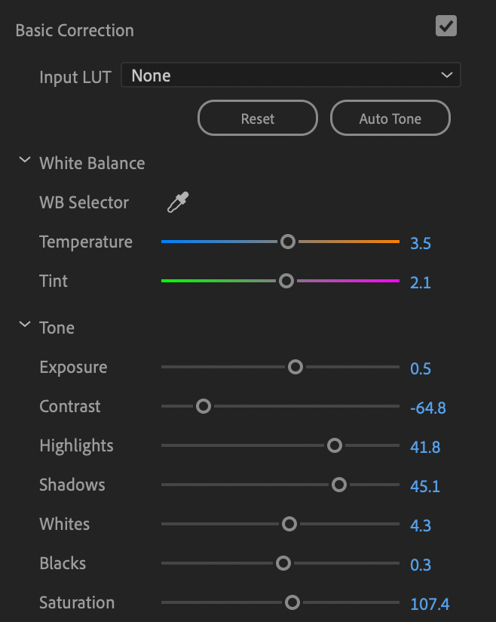

Cutting
- Remove uhs/umms and ramble. Pretty straightforward for retention - cut the noise.
- Keep total length ≤ 60s (unless you're going for long form ads).
- Use shortcuts - Example: I use E to cut, and Q/W to trim forwards or backwards.

Zoom-ins
Every 2-4 seconds, we’ll add some dynamic elements in the video (dynamic = opposite of a flat boring video).
Something like 100;Scale > 110;Scale gives a dynamic feel.
- Don’t overuse movements; use only when you want to emphasize something. Excessive use can hurt retention.

Music
A core component to make the video feel dynamic.
Now let me be clear here - there’s not a specific type of music that converts. There’s a specific audience that connects to it/the pace of it. I’ve seen fast-paced rap instrumentals work great for video ads in lots of demographics - but it doesn't mean it fits all people/brands, so keep that in mind.

In terms of where I get my music from, it’s just YouTube. I use this mp3 downloader, but feel free to pick from any one that you like (be careful of ads/viruses!)

Licensing & rights: As I said before, if you don’t have the right to an asset you use, you can get it shut down, but honestly, it’ll probably never happen. If you want to feel 100% sure, just search for music/fonts/brolls that are “free for profit”

B-Rolls
Once again, we want to add dynamics.
I get a lot of my free-for-use B-roll from Pexels, Pixabay, or Freepik.

- Again, don’t overuse it. Use b-roll when you find an “empty/flat” part of the video.
- Make sure the b-roll represents the sentence behind it correctly.
- Pay attention to licensing rights

Captions
Crucial to simplify, enhance, and better the understanding of your viewers.

- Add small animations for a dynamic feel: even a small zoom in would make a huge difference [ 95;Scale > (2 frames) > 105;Scale > (2 frames) > 100;Scale ]
- Pick colors that are easy to read: if the screen is bright, make sure to contrast it with a darker color.

Hook
The hook is the first 2-5 seconds, and by far the most important component of the ad, and if you miss this crucial part, all the other parts become significantly meaningless. Imagine the hook as a literal hook that drags the viewer through different states/moods in a split second, followed by curiosity/anger/fear, or really anything that evokes powerful emotions/thoughts. These powerful emotions/thoughts will stop the person's activity in that moment and literally steal their attention.
Hooks can contain/invoke the following:
- Pain/Promise towards pleasure
- Controversial take
- Deep curiosity
- Shock

So this is how I usually go about hooks:
I take the scripted hook from the footage, apply a powerful sound like a pop, whoosh, alarm, warning, bass drop, notification etc..anything sudden that would catch my attention if I were walking down the street and minding my own business. Next, I’ll add one of the following: an Animated visual, a visually catching clip that contains shock, Zoom in/out.. It’s our main pattern breaker - so focus on it like the ad depends on it..because it does.

Sound Effects
Another crucial part for retention and dynamics, I usually add them near the end of the editing process.

Simple principles to follow when adding sound effects:
- Match Context: Adding unrelated/misaligned sound effects WILL create annoyance with your viewers, causing them to leave the video. So no, you shouldn’t add the “bruh” sfx when the ad shows client results.
- Don’t reuse: Reusing SFX too much can also cause annoyance, so change it up. To be clear, you can get away with adding the same sound if it’s in a further part of the video - in my experience, up to 3-4 times max (also depends on the sound).

If you’re wondering where I get mine, it's just YouTube.

Visual representation
Another dynamic element we use to make the video far more interesting is by visualising a sentence of the script. This is also a fantastic way to simplify whatever it is that you’re saying.
And as we already covered, simplicity is king.

I can’t give you an exact blueprint on this since every sentence would require a different visual, but I can give you some rough outline to follow:
- The visual MUST align with the sentence: a wrong visual will create confusion.
- Less is more: If you want to add something, but it doesn't contribute to the point of the visual, remove it. Simplify as much as you can.

Here’s a good way to check your visuals’ quality - ask yourself this:
“If I were watching this video for the first time on mute, would I be able to understand what’s being talked about in the video?”

Transitions
In my opinion, it’s optional. If you switch screens from footage > broll / footage > visual and vice versa, it can be a nice touch to add.

- Don’t overuse the same transition
- Use only when the screen changes

